

Island Food Rush

A concept

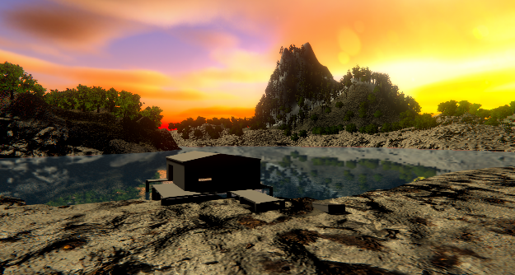

**Last Updated:**

11/5/2020

**Prepared By:**

Julian Frost

**TABLE OF CONTENTS**

**Game Pitch 3**

**Mission Statement 3**

**Genre 3**

**Platforms 3**

**Target Audience 3**

**Storyline & Characters 4**

**Gameplay 5**

**Overview of Gameplay 5**

**Player Experience 5**

**Gameplay Guidelines 5**

**Game Objectives & Rewards 5**

**Gameplay Mechanics 5**

**Level Design 6**

**Control Scheme 7**

**Game Aesthetics & User Interface 7**

# Game Pitch

This game is mostly an experience. It also has a collect-a-thon feel to it because you’ll have to collect food coins in order to pay back someone for breaking something of theirs. A game of redemption.

# 

# Mission Statement (Condensed Game Pitch)

You are a person in debt for touching something that’s not yours. Go redeem your self for you foul deed.

# Genre

Exploration, Simulation, platformer, collect-a-thon

# Platforms

Windows PC, Mac

# Target Audience

Children ages 6-12 might enjoy games like this because it looks nice and they’d have to collect things like coins or food. This game can also teach child a lesson about not touching what’s not theirs. Older people will understand the message but not really be as interested in playing through. They might just want to walk around. Younger would probably struggle with the controls

# Storyline & Characters

You are a lost soul on an island who wants to leave. As you find a boat you realize that is disappears and breaks. You have to find the food coins as a repayment for breaking the boat that didn’t belong to you. Maybe it is a dream…

|  |  |  |  |
| --- | --- | --- | --- |
| Character | Description | Characteristics | Misc. Info |
| Character Name  Fhil | Describe the character. It is the main playable character that you take control of. | Emotionless (space to project onto him) | He can jump and summon cubes for some reason |
| Doc Dude | Lives in shack by boat. faceless | faceless | He loves food coins |

# Gameplay

## Overview of Gameplay

- WASD movement

- First person POV

- Jumping

- R summons a platform to help reach higher places

## Player Experience

Your character will move considerably fast and be pretty agile as they move around on the island to collect food coins.

## Gameplay Guidelines

No violence, under 3:00 (quick)

## Game Objectives & Rewards

This is where you present more details on how the gameplay will motivate the player to progress through the game. Discuss rewards and penalties and the difficulty level. You can use the table below to help break down objectives and rewards.

|  |  |  |
| --- | --- | --- |
| Rewards | Penalties | Difficulty Levels |
| Collect all coins means Doc Dude forgives you | Don’t finish and Doc dude will stay mad at you | N/A |

## Gameplay Mechanics

|  |  |
| --- | --- |
| **Character Attributes** |  |
| **Character** | **Movement Abilities / Actions Available** |
| Fhil | WASD movement  Summon platform with R |
|  |  |
| **Game Modes** |  |
| Game Mode / Difficulty Name | One game mode and one difficulty |
| **Scoring System** |  |
| **Points/Coins/Stars/Grades/Etc.** | **How it’s Awarded & Benefits** |
| Score reflected on HUD | Each food coin gain adds +1 to score |

## Level Design

|  |  |
| --- | --- |
| **Levels** |  |
| Level name and/or pic of it | Island of dreams. An island with nice greenery and deceptively hard terrain to traverse the deeper in you go. Three big Food coins. |

# Control Scheme

|  |  |
| --- | --- |
| **Button/ Touch Input** | **Action it Performs** |
| WASD | Move laterally |
| Mouse | Look around |
| R Key | Spawn platform |

# Game Aesthetics & User Interface

Character is a capsule because it’s simple and no one else has to look at them. Wanted the island to feel warm in inviting like a dream. Tried to accomplish this via warm lighting from the sun. the food coins don’t really fit the realistic aspect because its not suppose to. Kids tend to move towards big objects of interests. So the coins being big an cartoony should help collecting them easier. UI is cluttered but give useful information on what’s happening